Task 3

Data analysis and cleaning:
- To start with, we first observe the distribution of private and non-private universities in the dataset. It is skewed and there are more private universities comparatively. This tells us that we stratify the data while model training.
- Next, we drop the first column ‘Unnamed: 0’ as it contains university names and no values which can be used to predict or identify type of university.
- We now identify what features will help the models to distinguish between the 2 categories. Thus, we create boxplots for all features against the target variable ‘Private’.
- Features Top25perc, Books, Terminal, Top10perc and PhD don’t seem to differentiate clearly, hence we drop these columns from the dataset.
- Next, we perform an overall data check. The Grad rate column seems to have max value as 118 which is strange as rates can only be up to 100. Therefore, we replace such value(s) by 100.
- There are no nulls in the data.
- Lastly, we split the dataset into stratified train and test segments with a train size of 70% and normalize them.
Logistic Regression:
- After training the model and testing it, it is observed that the results of classification are decent with F1-scores of 0.96 and 0.88 for Private and non-Private universities respectively.
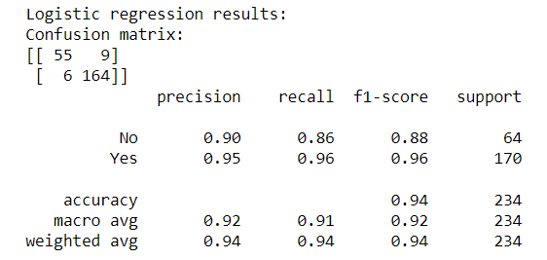
K-means clustering:
- After training the model and testing it, it is observed that the results of clustering are not too bad, with F1-scores of 0.75 and 0.65 for Private and non-Private universities respectively.
- Note: It is not clear which category has the clustering algorithm considered as Private and which, non-Private. The cluster labels in the output were simply 0 and 1, so we’ve assumed that 0 stands for non-Private and 1 stands for Private.
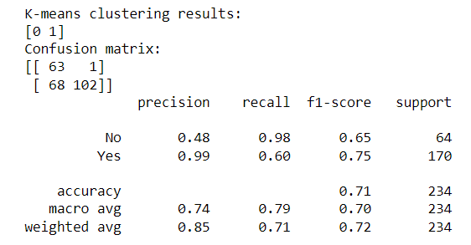
Conclusion:
It is observed that classification using logistic regression performs better than clustering using k-means. One reason can be that there are many outliers present in the data which may be useful for classification but affect clustering, as k-means algorithm is sensitive to them.
Example of outlier:
